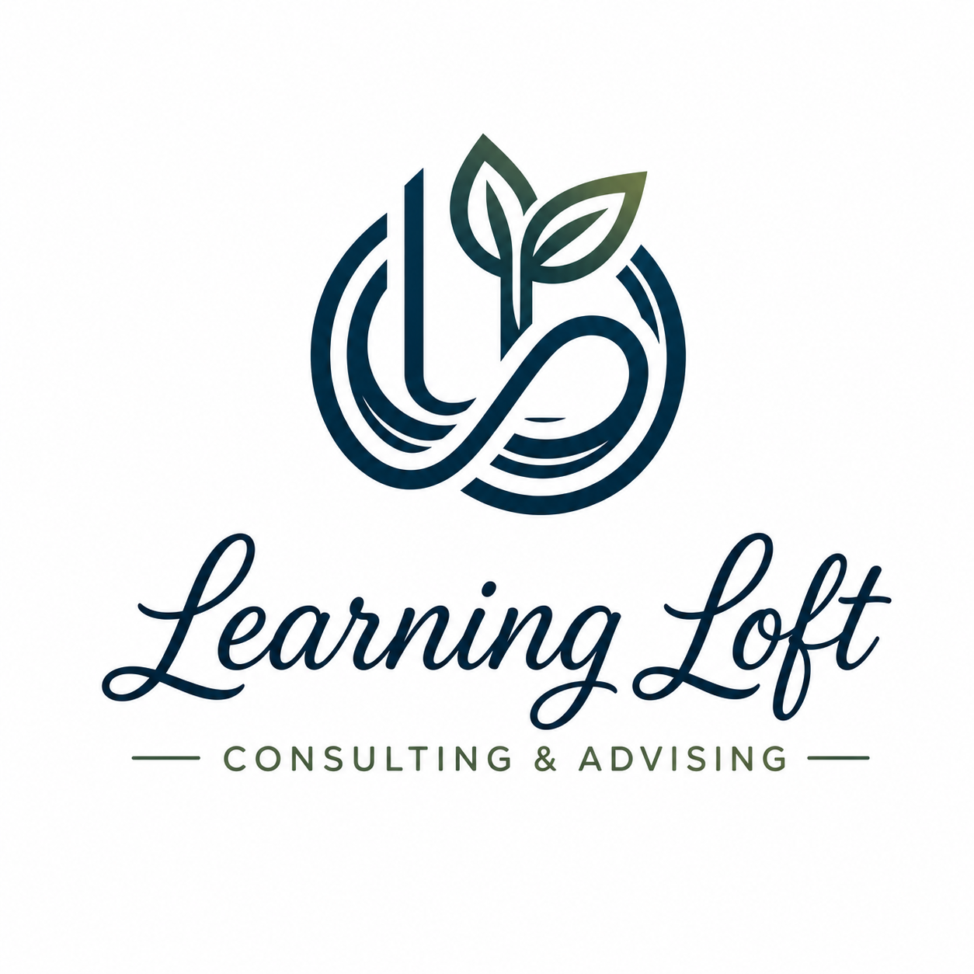
Hearing & Deaf / Hard of Hearing
Consultant Quick-Reference Sheet
Use this guide when a client discloses a hearing impairment or communicates a need for accommodation.

Your role as a Learning Loft consultant
You are not expected to be a disability specialist. You are expected to be responsive, flexible, and professional. If a client discloses a hearing-related need, this sheet gives you the steps and tools to serve them well.

Step 1 — When a Client Discloses a Hearing Need
If a client mentions they are Deaf, hard of hearing, or have difficulty with audio during a session, respond with:
- Acknowledgment — thank them for letting you know
- A quick check-in — ask what works best for them
- Flexibility — be ready to adjust your session format

Sample language you can use:
"Thank you for sharing that with me. I want to make sure our session works well for you — can you tell me what communication method works best? I have a few options available and I'm happy to adjust."

Step 2 — Communication Options to Offer
Option A: Google Meet with Live Captions (Recommended)
Google Meet has built-in live captioning that displays real-time text of everything spoken during the session. This is your best tool for serving hard-of-hearing clients in a virtual setting.
How to turn on captions:
- Open your Google Meet session
- Click the "CC" button at the bottom of the screen
- Captions will appear in real time for all participants

- Captions are available to all participants — no special setup needed on the client's end
- Encourage the client to also turn on captions from their own screen for the clearest experience
- Speak clearly and at a moderate pace — this improves caption accuracy

Option B: Written / Chat Communication
If a client is fully Deaf and does not use voice, offer to conduct the session primarily through Google Meet's chat feature or via email exchange.
- Use Google Meet chat for real-time written communication during the session
- For clients who prefer asynchronous communication, offer a structured email exchange as an alternative to a live session
- Follow up every session with a written summary of key points and next steps — this is good practice for all clients and essential for those with hearing needs

Option C: Sign Language Interpreter
If a client uses American Sign Language (ASL) and requests an interpreter, this is a reasonable accommodation request. Steps to take:
- Note the request and the client's contact information
- Contact Learning Loft at advising@learningloftadvising.com to discuss options
- Do not decline the client or reschedule indefinitely — hold the session in a written format while interpreter arrangements are explored

Option D: TDD / TTY (Phone-Based Clients)
TDD (Telecommunication Device for the Deaf) and TTY are phone-based text communication systems some Deaf clients may use. Google Meet does not have native TDD/TTY support.
If a client specifically requests TDD/TTY:
- Acknowledge the request professionally
- Offer Google Meet with live captions as a modern equivalent
- If the client cannot use video conferencing, flag the request to Learning Loft so we can explore phone relay service options (711 Relay Service)

Step 3 — During the Session
- Turn on captions at the start of every session when a hearing-impaired client is present
- Speak one at a time — avoid talking over each other, which degrades caption accuracy
- Use the Google Meet chat window to reinforce key points in writing during the session
- Avoid relying solely on verbal summaries — follow up in writing
- Ask at the start: "Is there anything I can do to make this session more accessible for you today?"

Step 4 — After the Session
- Send a written session summary via email, even if not requested — this is a best practice and an accessibility support
- Note the client's preferred communication method in your records for future sessions
- If the session was challenging to conduct effectively due to accessibility barriers, flag it to Learning Loft so we can improve our support resources

Important: What you should NOT do
Do not cancel or discourage a client because of a hearing impairment. Do not assume what a client needs — always ask. Do not promise services (like interpreter services) without first checking with Learning Loft.

Quick Resource List
- Google Meet live captions: support.google.com/meet
- 711 Relay Service (phone relay for Deaf/hard of hearing): dial 711 or visit fcc.gov/consumers/guides/711-telecommunications-relay-service
- National Association of the Deaf: nad.org
- Learning Loft support: advising@learningloftadvising.com

